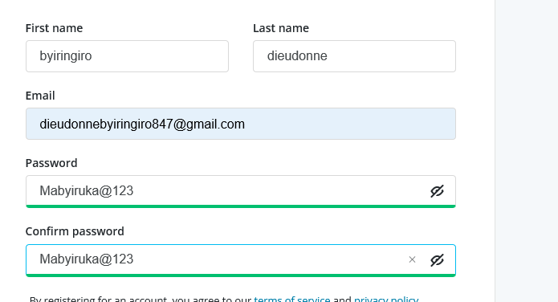

I totally need ALU financial aid to complete my studying, because I live with my mother and my sister they have no job, no enough land. My mother is a farmer that what she has been doing since I was a child for us to live, our father left us when I was a child and I we don’t get any help form him. All what we earn from agriculture ends up for home consumption life food, water, insurance and other basic needs. We end up not even saving any at what we earn. It is very hard to pay for the insurance sometimes we get help form the government. Since I was a child I was under child sponsorship program at New Life Ministries, we could be renting now but the sponsorship program helped us own our own small house, I couldn’t even be able to finish my high school without the sponsorship program. The sponsorship program ends with high school so I definitely need ALU financial aid to continue with my studding and impact my society and develop myself, family and the country in general. And I love ALU university because I heard a lot form you about impacting the Rwandan/Global society in addition to that I wish I could be one of your members. Thank you!!

